Library Learning Commons Application
*Here is a preview of what the Library Learning Commons Application looks like. Use it to type your responses prior to filling out the actual application online. Then when ready click on the Learning Commons Application Link and copy and paste your responses into the online survey.
Background Information
It's an exciting time for our students as we transition our media centers into future ready Library Learning Commons, designed as engaging and flexible learning environments for our students as digital learners. But what exactly should a Learning Commons in Cobb look like? Since the Learning Commons reflects the culture and community of a school, no two will look exactly alike. There are, however, concepts of instructional programming and design that are embodied in every Learning Commons. As you complete this application, please keep the following ideas in mind:
- The Learning Commons represents a philosophy of flexible learning in programming and design, centers on collaboration, encourages innovation, and incorporates the unique culture of the local school community.
- All Learning Commons are user-centered and provide information resources, productivity tools, and services to support and accelerate student learning (Pressley, 112).
- The Learning Commons continues to support teaching and learning, but also provides space for “experimenting, playing, making, doing, thinking, collaborating, and growing” (Loertscher, E3).
- Through the instructional leadership and collaborative work of the Library Media Specialist (LMS), students learn digital literacy skills, engage in creative thinking, and are prepared for their futures.
- Scheduling of the Learning Commons is flexible, rather than fixed, at least 75% of the school day.
- The spaces and instruction are designed to reflect the learning goals and culture of the school while encouraging creativity, digital literacy, and innovation.
Sources
Loertscher, David V., and Carol Koechlin. "Climbing to excellence: Defining characteristics of successful learning commons." Knowledge Quest 42.4 (2014): E1. http://www.ala.org/aasl/sites/ala.org.aasl/files/c...
Pressley, Lauren. "Charting a Clear Course: A State of the Learning Commons." ACRL. N.p., 22 Mar. 2017. Web. 9 July 2017. http://www.ala.org/acrl/sites/ala.org.acrl/files/c...

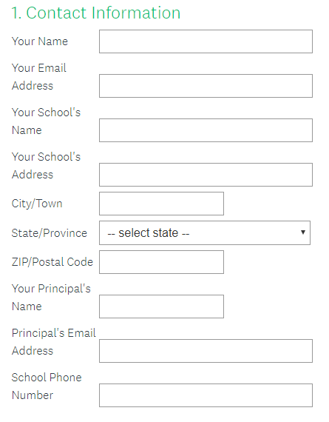

Services
A Learning Commons can provide many and varied services to support instructional goals and student engagement. Below are examples that can be included in your response, but you are not limited to these.
- Instructional partnerships and leadership
- Collaborating with teachers across grade levels and subject areas
- Collaborating with teachers about STEM challenges
- Promoting a culture of reading
- Promoting a culture of inquiry, creativity, and innovation
- Providing large group instruction in effective practices for research, using the Cobb Digital Library, creating products through digital tools, and using productivity resources to support instructional standards and/or STEM
- Providing ongoing support to classes and individual students throughout short and long-term assignments
- Individual and small group technology and/or production support
- Professional learning (individual, small group, or large group)

2. Describe the services provided in your Library Learning Commons. How do they represent the Learning Commons philosophy and your school's learning culture?

Resources
A Library Learning Commons continues to provide print and digital resources while also supplying new and innovative resources designed to stimulate critical thinking and creativity. Below are examples of resources that can be included in your response, but you are not limited to these.
- Print and digital reference resources (including and in addition to the CDL)
- STEM instructional resources and productivity tools (not materials)
- Genrefication of the print collection
- Easily accessible technology (desktops, laptops, tablets) available in the Learning Commons.
- Video production resources (green screen, cameras, apps, etc.)
- Additional creative tools and innovative resources (Legos, Robotics, Coding, Circuits, 3D printer, etc.)
3. Describe the information and technology resources that are provided in your Library Learning Commons. How do they represent the Learning Commons philosophy and support your school's learning culture?

Intentional Spaces
A Learning Commons should be designed with intentional spaces, meaning that all areas have a designated and useful purpose for the school's instructional goals and culture, while still allowing for flexibility. Below are examples that can be included in your response, but you are not limited to these.
- Flexible furniture, such a mobile tables and chairs
- Flexible schedule controlled by the Library Media Specialist
- Large group instruction area
- Collaborative small group work spaces
- Support for digital tools and BYOD, such as easily accessible power
- Quiet/independent areas
- Soft seating
- Makerspace or an area where maker-inspired programming can be brought in

4. Describe the instructional spaces and areas in your Library Learning Commons. How do they represent the Learning Commons philosophy and the school's learning culture?

Additional Evidence
Along with your application, please provide a letter from your current principal endorsing your Library Learning Commons, along with 2 other pieces of evidence showing examples of how your Learning Commons' spaces, services, and/or resources are being utilized. Below are some examples of types of evidence you can use, but you are not limited to these:
- Video of a lesson, interviews with students, or a STEM visit
- Video of students working
- Examples of finished products
- Teacher input (a typed letter from the teacher or video interview)
5. Evidence 1: Principal's letter of endorsement.
Upload a letter of endorsement from your current principal or assistant principal explaining their support of your Library Learning Commons.

6. Evidence 2:
Upload evidence here or insert a link. If providing a link insert it into a DOC and upload the file.

7. Evidence 3:
Upload another piece evidence here or insert a link. If providing a link insert it into a DOC and upload the file.

