Name:
Period:

On March 11, 2011, there was a large nuclear disaster at the Fukushima Daiichi Nuclear Power Plant in Japan. This image was posted on Imgur, a photo sharing website, in July 2015.

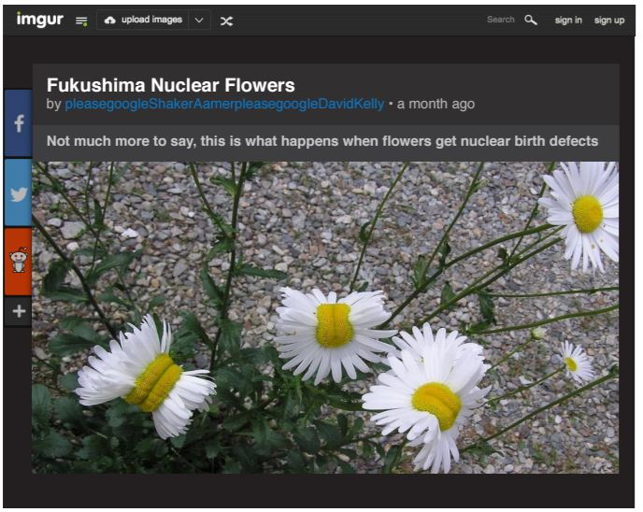
Using the rules for fake news decide if this picture is real or fake. How can you tell? What rules did you use? __________________________________________________________________________________________________________________________________________________________________________________________________________________________________________________________________________________________________________________________________________________________________________________________________________________

